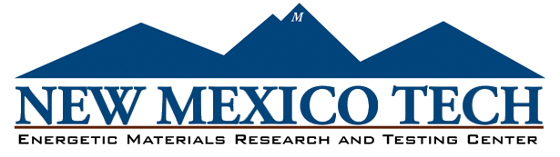

1001 South Road, Socorro, NM 87801 – Phone: (575) 835-5312 – Fax: (575) 835-5630 – [www.emrtc.nmt.edu](http://www.emrtc.nmt.edu)

Working to Make People Safe Since 1947

***Purchasing Services Office***

801 Leroy Place

Socorro, NM 87801

(575) 835-5881

***Letter of Addendum***

TO: All Bidder’s

FROM: Francesca Smith, Buyer II

DATE: 07/20/2023

RE: RFB Number: RFB# 0021190E, Amendment No. 1 Commodity: Drones, Accessories and Training

*Please note:*

This amendment is issued to provide a list of questions that have been received by NM Tech.

Q1) We can submit a quote for the hardware (Drones & accessories) just not the training.

Are you accepting quotes **without** training? Or is this an **ALL OR NONE**?

A1) We are looking for all or none. In the past we have skipped the training only to find out through damage to the new equipment that we should have had the training first. These are expensive items and the training is a little bit of insurance that we truly understand the systems before taking them out and flying them.

**All other terms and conditions of the RFB remain unchanged. All Offerors are required to confirm the receipt of this amendment in their bid response.** The proposal due date is July 28, 2023 at 2:00 p.m. MST.

Xc: File