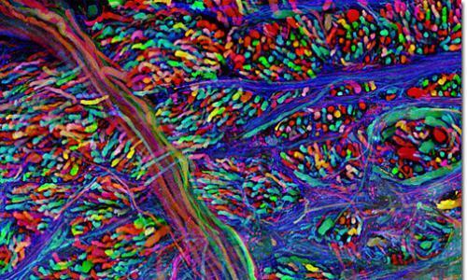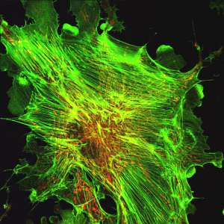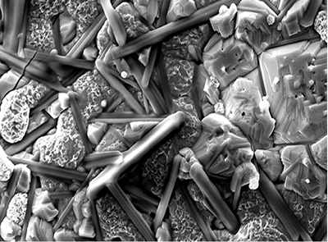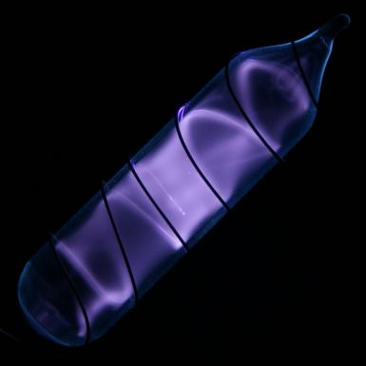

1. Individuals working in a laboratory setting

* Performing all work in a safe manner
* Using available PPE and engineering controls.
* Following lab-specific safety policies and procedures.
* Completing safety training assigned by your supervisor.

1. Faculty, Principle Investigators and Laboratory Supervisors

* Documenting appropriate hazard assessments for the work being performed.
* Ensuring that appropriate laboratory engineering controls are available and working.
* Providing appropriate personnel protective equipment (PPE) to workers.
* Establishing lab-specific safety policies/ procedures for lab workers.
* Ensuring all workers have completed required safety training.

2015-2016

## *Basic Responsibilities*

# *A Quick Guide to Laboratory Safety Inspections At NMT*

This guide is developed to help the faculty, principle investigators, laboratory supervisors, laboratory assistants and students quickly assess the safety readiness of laboratories. This quick guide will briefly discuss topics that are addressed in the laboratory safety inspection checklist used by NMT Hazardous Waste Management team.

NMT Hazardous Waste Management Team

***NMT Lab Safety Inspection Guide***

1. Entry Door Postings

* Primary Area Contacts
  + Permit holder (Chemical/ Radiation/ Biosafety/ Laser) names and phone numbers (primary and after-hour phone number.
  + For areas with multiple permit holders the contact information for all permit holders should be listed.
* Second Area Contacts
  + Name and phone number (primary and after-hours numbers) of at least one knowledgeable secondary contact.
* Other Area Contacts
  + Depending on the type of lab, additional contact information may be needed. For example:
    - Departmental Safety Officer.
    - NMT Radiation and/or Biosafety Officer.
    - Building Monitor.
    - NMT Hazardous Waste Management Team.
    - NMT Campus police.
    - Other contacts (i.e. 911)
* Area Hazards
  + Post general hazards that may be found in the laboratory. Examples include:

-Corrosives -Oxidizers

-Explosives -Toxics

-Compressed Gasses -Radiation

-Biological

* Other Information
  + Post other entry requirements and pertinent information such as:
    - Area PPE requirements like “Safety Eye Protection Required.”
      * Note: If PPE is not required to be worn at all times in that area then don’t post the door with that requirement.
      * Lab Food and Drink Policy
        + There must be a sign posted with “No Food or Drink” warning, however if there are specific areas within the lab where food is allowed (i.e. an internal break room or office) the postings should be changed to a “Food and Drink is Allowed Only in Designated Areas” warning.
        + Areas inside the lab where food/drink are allowed must be clearly marked as designated food/drink allowed areas and be segregated from areas where hazardous chemicals are being used or stored.

gguu

gguu

## *Safety Signs and Postings*

## *Laboratory Safety Equipment*

1. Portable Fire Extinguishers

* Located within chemical work or storage areas ( in lab or hallway)
* Access must be free of obstructions
* Properly mounted on a wall and not sitting on the floor.
* Fully charged
* Security seal is intact.
* Inspected within the last year (tagged).

1. Emergency Safety Showers/ Safety Eyewashes and/or Sink Drench Hoses

* Available within 10 seconds of travel time.
* Access must be free of obstructions.
* Marked with a sign.
* Operational.
* Inspected within the last year (tagged).

1. Chemical Spill Kits

* Spill kits, appropriate for the chemicals in the area, must be available and dully stocked.
* Spill procedures must be available.
* Workers must be trained to lab-specific spill procedures.

2.) Emergency Phone Numbers Posting

* Emergency phone numbers must be posted near all phones in the laboratory.

3.) Laboratory Refrigerators, Freezers and Microwave Ovens Posting

* Equipment must be posted with a “No Food or Drink” sign.

4.) Emergency Safety Showers and Safety Eyewashes

* Must be clearly marked with a sign.

5.) Hydrogen Gas Cylinder Posting

* Area near compresses gas cylinders of hydrogen must be posted with a “HYDROGEN-FLAMMABLE GAS-NO SMOKING- NO OPEN FLAMES” sign.

6.) Exit Signs

* All exit doors must be marked with an exit sign.

7.) Area Evacuation Map

* A map showing egress routes and designated assembly locations must be posted in hallways outside of laboratories.

gguu

gguu

In hac habitasse platea dictumst.

gguu

gguu

4.) Personal Protective Equipment (PPE)

* Appropriate PPE must be readily available to workers.
* Workers must wear appropriate PPE for the activity being performed.
* Workers must comply with posted PPE requirements.

5.) Chemical Fume hoods

* Close chemical fume hood sashes when not working in the hood.
* When working in a hood, keep the sash in the lowest position possible except when adding or removing equipment.
* Ensure that hoods have a working flow indicator (manometer, paper strip etc.).
* Do not work with hazardous materials in a non-functioning fume hood.
* Ensure air flow is not blocked or inhibited prior to working.
* Elevate equipment at least 2 inches using blocks so air can flow underneath
* Ensure hood baffles or baffle slots are not blocked
* Minimize the amount of materials stored in a hood
* Do not store chemicals or chemical waste in fume hoods.
* Keep all materials and supplies at least 6 inches from the sash opening.
* Put an “Out-of-Service” sign on a hood that isn’t working and notify your building monitor.
* Put up a warning sign on unattended hoods when active operations are ongoing.

6.) Biological Safety Cabinets

* Do not work with hazardous biological materials in a non-functioning biosafety cabinet.
* Verify that the cabinet has been certified within the last year.
* Put an “Out-of-Service” sign on a biosafety cabinet hood that isn’t working and notify the NMT Biosafety Officer.

1. General Safety

* Ensure moving parts on mechanical equipment are properly guarded.
* Ensure stop switches and/or electrical disconnects are not obstructed and easily accessible.
* Secure heavy equipment to prevent it from tipping over.
* Place a warning sign on unattended equipment when it is operating (i.e. “Don’t Touch: Operation in Progress”).

## *Mechanical Equipment Safety*

1.) Lab-Specific Emergency and Spill Response Procedures

* Lab-specific emergency procedures must be available to workers. These procedures should include actions that workers should take in event of unusual or emergency situations such as
  + Power outages
  + Lab ventilation failure
  + Equipment emergency shutdowns procedures
  + Spill response

2.) Written Standard/Safety Operating Procedures (SOPs)

* Written procedures must be available to workers when handling hazardous material and/or performing hazardous processes.

## *Required Laboratory Safety Procedures*

1.) Housekeeping

* Area aisles and exit routes must be clear and free of obstructions (28 inch wide minimum)
* Area should be kept clean and well organized.
* Remove excess clutter.

2.) Eating, Drinking, Tobacco and Cosmetics

* Eating, drinking, using tobacco (Smoking, or chewing) or applying cosmetics in not allowed in areas where hazardous chemicals are used or stored.

3.) Laboratory Security

* Always keep unattended laboratories locked.
* Always secure hazardous material when unattended.

## *General Laboratory Safety*

gguu

gguu

gguu

gguu

1.) Extension Cords /Power Cords

* Use wire-mold or a floor cover kit wherever extension cords cross walkways so they don’t pose a tripping hazard.
* Extension cords may not be used for more than 90 continuous days.
* Do not run extension cords though walls, floors or ceiling panels.
* Daisy chaining extension cords, multi-outlet strips and/or surge protectors is not allowed.
* Do not use frayed or damaged power cords or plugs.
* Do not cut the ground prong off 3-pronged plugs.

2.) Surge Protectors / Multi-Outlet Strips

* Only use UL-listed multiple outlet strips with a 15 amp circuit breaker.
* Only use surge protectors on equipment that have a very light current load such as electronic / computer equipment.
* Do not daisy chain multi-outlet strips with extension cords.

3.) Ground-Fault Circuit Interrupters (GFCI)

* A Ground Fault Circuit Interrupter (GFCI) unit must protect electrical outlets within reach of a sink or other source of open water. These can be installed at the outlet or in the electrical panel.

4.) Electrical Panels / Electrical Disconnects

* Keep the area around electric circuit panels and

electrical disconnect switches clear of obstructions.

There must be at least 30 inches of unobstructed

clearance around them.

## *Electrical Safety*

1. Laboratory Chemical Inventories

* The senior staff, PI and faculty must maintain an inventory of all hazardous chemicals in the laboratory.
* Each laboratory must maintain a copy of the chemical inventory in the lab.

1. Chemical Safety Data Sheets (SDS/MSDS)

* SDS’s must be maintained in or near the lab for any hazardous chemicals in the area.
* SDSs must readily be available to all lab workers.
* Electronic SDS systems are allowed as long as all workers have access to the system.

## *Chemical Inventory/ chemical safety data sheets*

gguu

gguu

1.) Compressed Gas Cylinders

* Cylinders must be secured. An individual chain or cable is recommended.
* Cylinders must be capped when not in use.
* Regulators should be removed and the cylinder capped if it is not going to be used for an extended period of time.
* Cylinders must be labeled with the contents.
* Empty cylinders must be labeled “EMPTY”

2.) Plumbing and Tube Fitting

* Do not use Teflon tape on compression fittings. Teflon tape reduces the sealing ability of compression fittings.
* Ensure that the plumbing / tubing used downstream of regulator is designed to withstand the maximum discharge pressure of the regulator.
* Only use plumbing / tubing material that is compatible with the gas.

3.) Flammable/ Toxic/ Corrosive/ Oxidizing Gas (General Requirements)

* Do not store flammable gasses with oxidizing gasses.
  + Keep at least 20 feet of separation (or a wall with a . hour fire rating) between flammable and oxidizing gas cylinders.
* Do not store more than 3 oxygen and/or flammable gas cylinders in a laboratory.
* Toxic and corrosive gasses must be stored in a gas cabinet with a leak detection system.
* Toxic and corrosive gasses must be exhausted to the outside though a ventilation duct or fume hood.
* Toxic and corrosive gasses must have a Bonnet vent on the regulator which must be vented to the outside through a ventilation duct or fume hood.

4.) Hydrogen Gas (Specific Requirements)

* Areas near hydrogen gas cylinders must be placarded with a sign saying “HYDROGEN- FLAMMABLE GAS-NO SMOKING-NO OPEN FLAMES”.
* Cylinders must be at least 20 feet from flammable or oxidizing materials.
* Cylinders must be at least 25 feet from open flames and other potential sources of ignition.
* Cylinders must be at least 50 feet from:
  + Flammable gas storage areas,
  + HVAC intake vents
  + Air compressors.

## *Compressed Gas / Gas Cylinder Safety*

gguu

gguu

1.) Laboratory Waste Accumulation Point (WAP) & Waste Coordinators

* WAPs must be posted with a sign
  + Waste Coordinator name and phone number must be included on the sign.
* Waste Coordinators must complete EH&S Hazardous Waste Management training.
* Waste must be stored in the room it was generated and under the

control of the Waste Coordinator.

* No more than 55 gallons of normal hazardous waste or 1 quart

of acutely hazardous waste (RCRA P-Codes) can stored at a

Waste Accumulation Point.

2.) Waste Containers, Storage & Labeling

* Containers must be closed and labeled when not being filled.
* Unknown waste should be labeled “Hazardous Waste: To be

Determined”.

* Hazardous Waste tags must be affixed to each waste

container before pickup by NMT Hazmat.

* Waste container material must be compatible with the content.
* Feed lines draining into waste containers must form a snug, airtight fit.
* Do not fill liquid waste containers more than 75%.
* Liquid wastes stored on the floor must be in secondary containment.
* Incompatible wastes must be physically segregated.
* Do Not combine incompatible chemical wastes into the same

waste container.

## *Hazardous Chemical Wastes*

1.) Chemical Storage

* Store chemicals on sturdy shelves or cabinets.
* Do not stack chemicals containers on top of each other.
* Physically separate incompatible chemicals.
* Use secondary containment for liquid chemicals stored on the floor or near drains.
* Only use compatible materials for chemical drip trays and secondary chemical containers.
* Do not store liquids or large glass containers (> 500 mL) above eye level.
* Chemical containers must be closed and labeled when not in use.
* Use certified “Lab Safe” or “Explosion Proof” refrigerators / freezers for refrigerated flammable/ volatile chemical storage.
* Greater than 10 gallons of flammable liquids must be stored in an approved Flammable Cabinet.
* High hazard chemicals (i.e. acutely toxic, carcinogens, radioactive material) must be stored separately from other chemicals in marked storage.

2.) Chemical Container Labeling

* Chemicals containers must be closed and labeled when not in use.
* Secondary container labels must include:
  + Full name of the chemical (no acronyms)
  + Hazard statement (preferably GHS system label or NFPA diamond).

## *Chemical Storage/ Chemical Labeling*

gguu

gguu

*Safety Training will be implemented within the next year and the following lists general requirements for employees:

1.) General Requirements

* Hazmat class: will be required for anyone who is working with any kind of hazardous material.
* Lab Standard Training: will be required for laboratory workers working in labs that have hazardous chemicals.
* Hazard Waste Management: will be required for lab safety officers or waste coordinators.
* Specialized Safety Training: will be required for workers handling specialized hazards such as radioactive or biological materials.

## *Safety Training*